# _________________ RANDOM NUMBER GENRATION OF NEGATIVE BINOMIAL DISTRIBUTION ____________

#_______________________WITH BERNOULI AND GEOMETRIC GIDTRBUTION __________________________

# Geometric Generation (with Bernouli)

ber.gen<-function(p, size){

X<-NULL

for (i in 1:size){

x<-ifelse(runif(1) < p, 1, 0)

x<-append(X, x, after = length(x))

}

return(x)

}

geom.gen<-function(p, size){

x<-NULL

for(j in 1:size) {

i = 0

s = 0

while(s < 1){

s<-ber.gen(p,1)

i=i+1

}

x<-append(x, i-1, after = length(x))

}

return(x)

}

mean(geom.gen(0.5, 500))

hist(geom.gen(0.5, 500))

# _______ Use above geometric distribution for negarive binomial

# Negative Binomial

nb.gen<-function(r, p, size){

X<-NULL

for(i in 1:size)

X<-append(X, sum(geom.gen(p, r)), after = length(X))

return(X)

}

nb.gen(8, 0.9, 4)

mean(8, 0.9, 4)

hist(nb.gen(8, 0.9, 4))

***OUTPUT***

> # _________________ RANDOM NUMBER GENRATION OF NEGATIVE BINOMIAL DISTRIBUTION ____________

> #_______________________WITH BERNOULI AND GEOMETRIC GIDTRBUTION __________________________

>

> # Geometric Generation (with Bernouli)

>

> ber.gen<-function(p, size){

+ X<-NULL

+ for (i in 1:size){

+ x<-ifelse(runif(1) < p, 1, 0)

+ x<-append(X, x, after = length(x))

+ }

+ return(x)

+ }

>

> geom.gen<-function(p, size){

+ x<-NULL

+ for(j in 1:size) {

+ i = 0

+ s = 0

+ while(s < 1){

+ s<-ber.gen(p,1)

+ i=i+1

+ }

+ x<-append(x, i-1, after = length(x))

+ }

+ return(x)

+ }

> mean(geom.gen(0.5, 500))

[1] 1.118

> hist(geom.gen(0.5, 500))

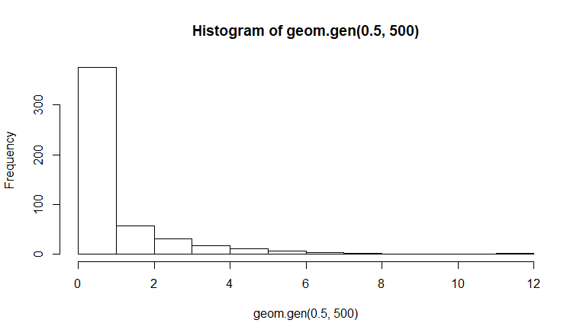

>

> # _______ Use above geometric distribution for negarive binomial

>

>

> # Negative Binomial

>

> nb.gen<-function(r, p, size){

+ X<-NULL

+ for(i in 1:size)

+ X<-append(X, sum(geom.gen(p, r)), after = length(X))

+ return(X)

+ }

> nb.gen(8, 0.9, 4)

[1] 0 0 1 0

> mean(8, 0.9, 4)

[1] 8

> hist(nb.gen(8, 0.9, 4))

